PT 8635
AES/EBU Audio Generator

The PT 8635 AES/EBU Audio Generator can be installed in the PT 5210 VariTime™ Digital Sync generator and in the PT 5230 Digital Video Generator.

Packing list:
Check that the PT 8635 option package contains the following items:
 | Description: | Item | Quantity
 | Nut for BNC Connector | 2422 034 17419 | 1
 | Lock washer for BNC Connector | 2422 034 17421 | 1
 | Pan Head Screw M3x6 | 2522 178 31058 | 10
 | Curved Spring Washer | 2522 728 04003 | 2
 | Ribbon Cable with micro 20 pole connectors | 4008 105 04030 | 1
 | Cable assy coax MCX/BNC | 4008 105 04440 | 2
 | Cable assy with XLR male | 4008 105 04880 | 1
 | AES/EBU Audio/Word Clock | 4008 109 84820 | 1

The system is “plug and play” meaning that when the unit is mounted no configuration is needed in order to enable the PT 8635.
Installation procedure:
- Open the PT 5210/PT 5230 by removing the top cover.
- Remove all plastic blinds from the back panel for the BNC and XLR connectors marked AES/EBU Audio, WORD CLOCK, and SILENCE (PT 5210).
If the “TIME CODE” XLR is not used, remove the plastic blind.
- Insert the PT 8635 AES/EBU audio generator module.
- Mount the lock washer and nut on the BNC connector on the module and the screws on the XLR connector, do not tighten.
- Mount the 8 screws to fasten the PT 8635 AES/EBU audio generator module, do not tighten.
- Tighten the nut on the BNC connector and the screws on the XLR connector.
- Tighten the screws holding the module in the frame. Install the two cables with BNC connectors. The BNC connectors should be installed in the holes marked WORD CLOCK, and AES/EBU2/SILENCE.
- Connect the two coaxial cables on the module to the connectors marked: CX2 AES/EBU2 and CX3 WC#1.
The cable from AES/EBU2/SILENCE should connect to CX2 and the cable from WORD CLOCK should connect to CX3.
Please note: The PT 8635 deliver SILENCE only on the AES/EBU2 output when used in a PT 5210.
- If no “TIME CODE”, install the XLR cable assembly.
- Connect the cable from TIME CODE to XC2.
- Install the cable connecting the unit to the board in front of the module, a guide pin in each connector has to fit into a similar hole in the modules.
- Mount the top cover on the PT 5210/PT5230.
- Turn on power, and observe that the menu includes the AES/EBU audio generator.
- Place the new option type plate on the side of the generator in order to make later identification possible.

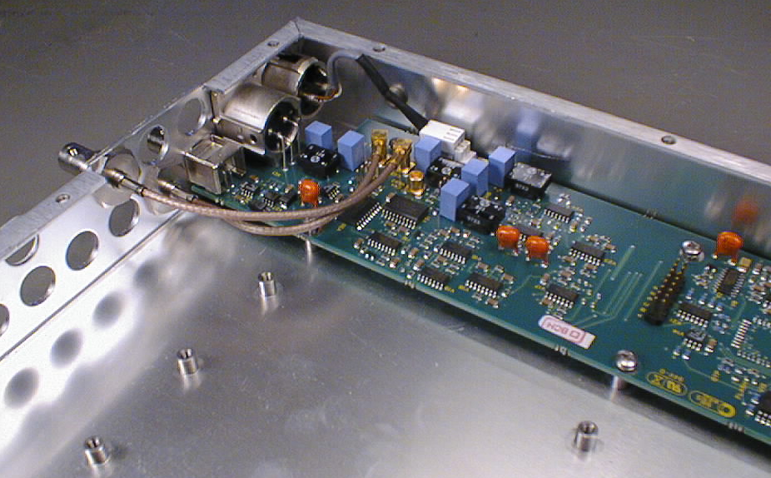
Picture 1: The positioning of the PT 8635 AES/EBU Audio module in a PT 5210/PT 5230.

